# Function notes

* res.send()
  + use: sends the HTTP response, ends all writing to the response stream
  + parameters: the only parameter is the body which is to be sent in the response
  + returns: an object
* router.post(...)
  + use: send information to the db
* router.patch(...)
  + use: update operation on a single record
* router.delete(...)
  + use: deleting a record
  + nothing is returned to the user
* router.get(...)
  + use: get records

# Examples

* setting up a schema and naming it (under models/Post.js)

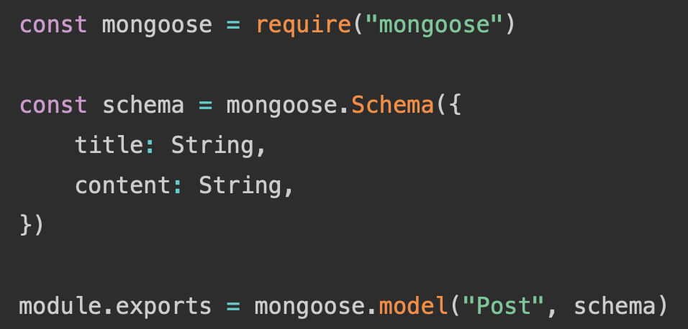

* get all posts

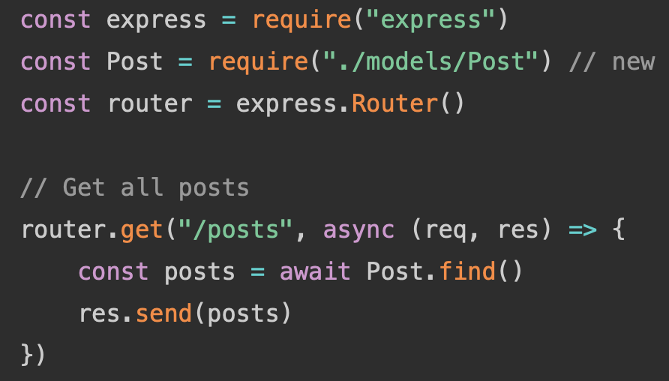

* get an individual post

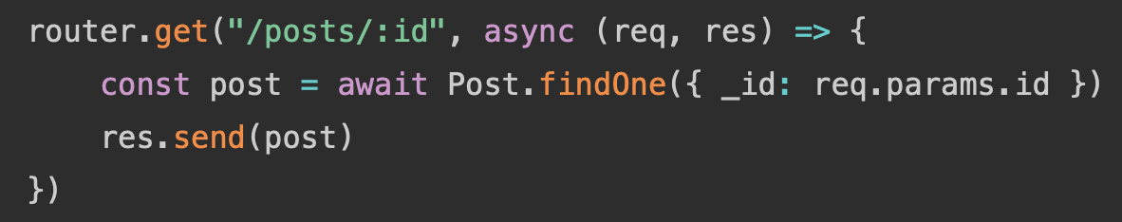

* sending a post (a Post model made through Mongoose) to the db

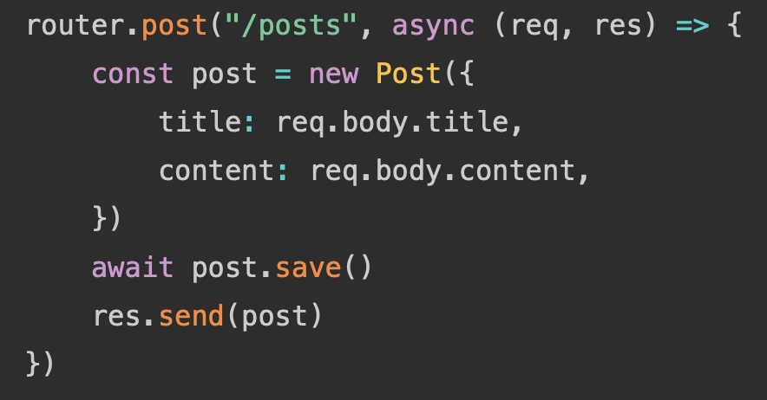

* grabbing a specific post using the id

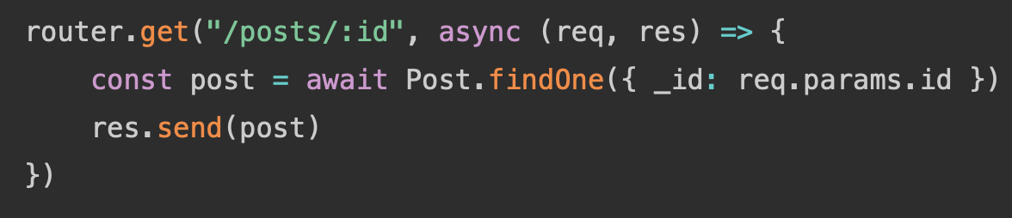

* catching an error when trying to retrieve information

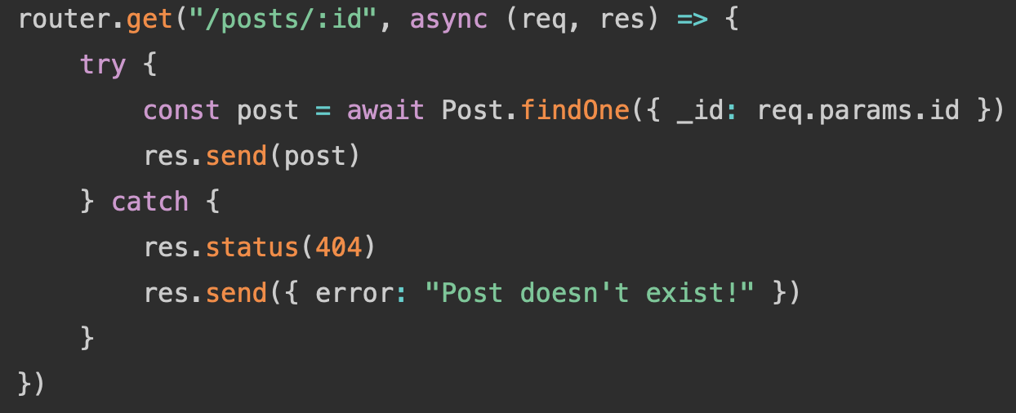

* updating a record

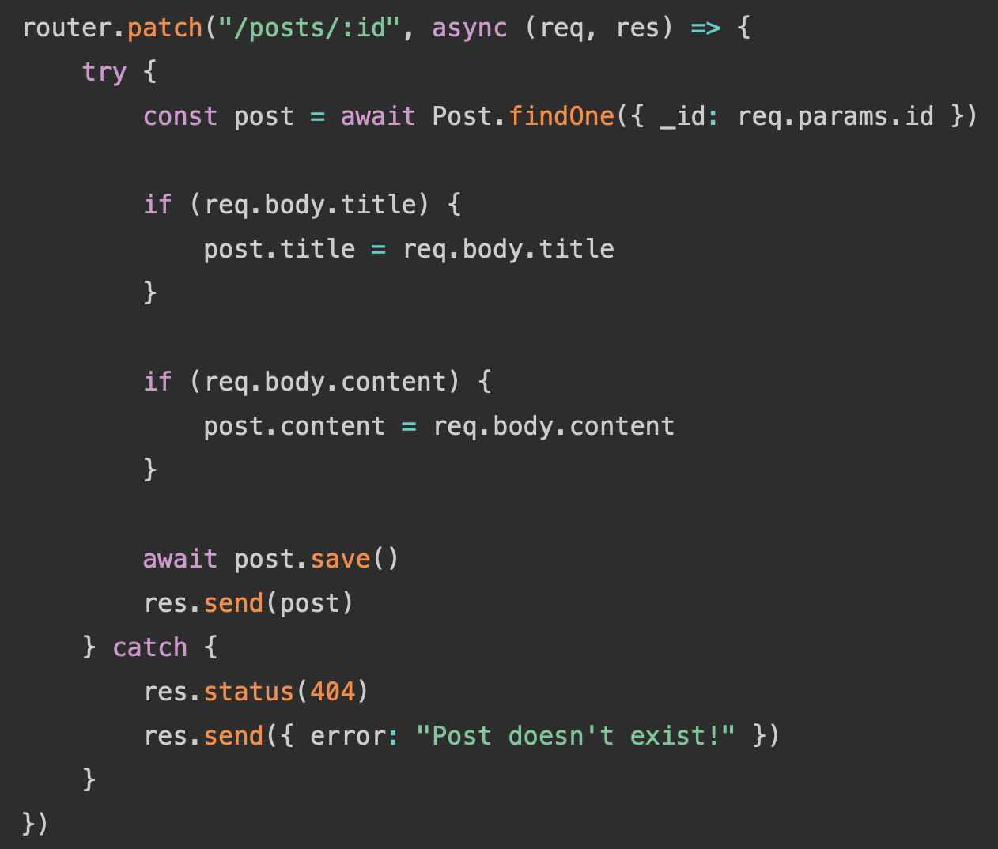

* deleting a record

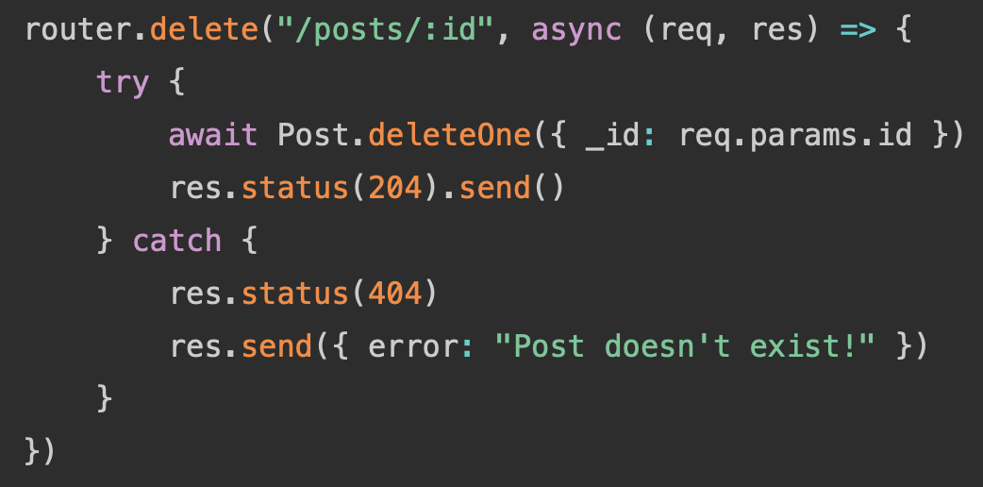

# Links

* <https://rahmanfadhil.com/express-rest-api/>